 | 12.1.41 Editors - Geometry Nodes Editor - Header - Add Menu - Color
Table of content
Detailed table of content 1
Add menu - Utilities - Color 4
Blackbody 4
Gamma 4
Color Ramp 5
RGB Curves 7
Mix Color 8
Combine Color 9
Separate Color 10

Detailed table of content
Detailed table of content
Detailed table of content 1
Add menu - Utilities - Color 4
Blackbody 4
Inputs 4
Temperature 4
Outputs 4
Color 4
Gamma 4
Inputs 4
Color 4
Gamma 4
Outputs 4
Color 4
Color Ramp 5
Inputs 5
Factor 5
Properties 5
Color Ramp 5
Controls 5
+ 5
- 5
Tools menu 5
Flip Color Ramp 5
Distribute Stops from Left 5
Distribute Stops Evenly 5
Eyedropper (pipette icon) E 5
Reset Color Ramp 5
Color Mode 5
RGB 5
HSV/HSL 5
Interpolation 6
Ease 6
Cardinal 6
Linear 6
B-Spline 6
Constant 6
Color Ramp 6
Active Color Stop elements 6
Choose active color stop 6
Pos 6
Outputs 6
Image 6
Alpha 6
RGB Curves 7
Input 7
Factor 7
Color 7
RGB Curve 7
C R G B 7
Selecting Points 7
Adding Points 7
Navigation elements 7
Zoom in 7
Zoom out 7
Clipping options 7
Tools 7
Reset View 7
Extend Horizontal 8
Extend Extrapolated 8
Reset Curve 8
Handles 8
Position X / Y 8
Delete Points 8
Output 8
Color 8
Mix Color 8
Inputs 8
Factor 8
A 8
B 8
Properties 9
Data Type 9
Blending Mode 9
Mix 9
Clamp Result 9
Clamp Factor 9
Outputs 9
Result 9
Combine Color 9
Input 9
Mode 9
Input – RGB mode 9
R, G and B 9
Input – HSV mode 9
H , S and V 9
Input – HSL mode 10
H , S and L 10
Outputs 10
Color 10
Separate Color 10
Input 10
Mode 10
Image 10
Output 10
Red, Green, Blue and Alpha 10
Hue Saturation Value Alpha 10
Hue Saturation Lightness Alpha 10

Add menu - Utilities - Color
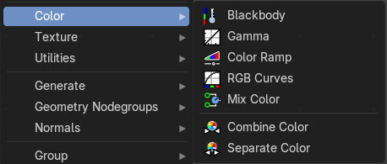
Here you find mainly nodes to convert color values.

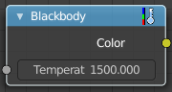
Blackbody
The Blackbody node converts a blackbody temperature to RGB value. This can be useful for materials that emit light at natural occurring frequencies.

Inputs

Temperature
The temperature in Kelvin.

Outputs

Color
RGB color output.

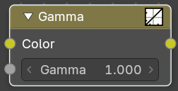
Gamma
Apply a gamma correction.

Inputs

Color
RGB Color input.

Gamma
The gamma correction value. 1 is unchanged.

Outputs

Color
RGB color output.

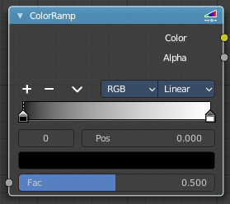
Color Ramp
The Color Ramp Node is used for mapping values to colors with the use of a gradient.

Inputs

Factor
The Factor input is used as an index for the color ramp.

Properties

Color Ramp
Color Ramps enables the user to specify a range of colors based on color stops. The color between the color stops gets interpolated.

Controls

+
Add a stop to your color ramp. The stop will be added after the selected one, in the middle to the next one.

-
Deletes the selected color stop from the list.


Tools menu

Flip Color Ramp
Flips the gradient, inverting the values of the color ramp.

Distribute Stops from Left
Rearrange the stops so that every step has the same space to the right.

Distribute Stops Evenly
Space between all neighboring stops becomes equal.

Eyedropper (pipette icon) E
An Eyedropper to sample a color or gradient from the interface to be used in the color ramp.

Reset Color Ramp

Resets the color ramp to its default state.

Color Mode

RGB
Blends color by mixing each color channel and combining.

HSV/HSL
Blends colors by first converting to HSV or HSL, mixing, then combining again. This has the advantage of maintaining saturation between different hues, where RGB would de-saturate, this allows for a richer gradient.


Interpolation

Ease
Uses an Ease Interpolation for the color stops.

Cardinal
Uses a Cardinal Interpolation for the color stops.

Linear
Uses a Linear Interpolation for the color stops.

B-Spline
Uses a B-Spline Interpolation for the color stops.

Constant
Uses a Constant Interpolation for the color stops.

Color Ramp
The color band. A click at one of the color stops makes it the active one. You can move the color stops by clicking at them and dragging them around.

Active Color Stop elements

Adjust the active color stop.

Choose active color stop
Choose the color stop by index.

Pos
The position of the active color stop. The range goes from 0.000 to 1.000

Outputs

Image
Standard image output.

Alpha
Standard Alpha Output.

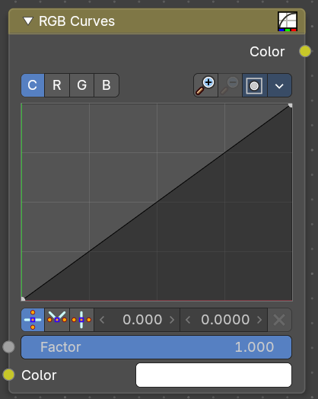
RGB Curves
Adjust the RGB channels by curves.

Input

Factor
The blend factor.

Color
The input color.

RGB Curve

C R G B
The color channels.


Selecting Points
You can select curve points. This reveals two edit boxes for the x and y coordinate of this point.
Selected points can be moved around. Left click at them, hold the mouse button down and move them to a new location.


Adding Points
You can add new curve points by simply left clicking at the curve. Move the mouse to position them where you need it.

Navigation elements

Zoom in
Zooms in.

Zoom out
Zooms out.

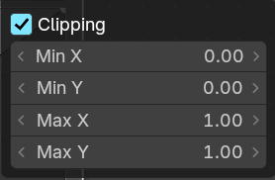
Clipping options
Set up clipping for the stroke.

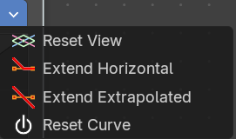
Tools
Tools is a menu where you can find some curve related tools.

Reset View
Resets the curve windows zoom.

Extend Horizontal
Extend the curve before the first and after the last point horizontal.

Extend Extrapolated
Extend the curve before the first and after the last point extrapolated.

Reset Curve
Resets the curve to the initial shape.

Handles
You can choose between Auto handle, Vector Handle and Auto Clamped.

Position X / Y
The position of the selectedc curve point.

Delete Points
Deletes the selected curve point.

Output

Color
The rgb output.

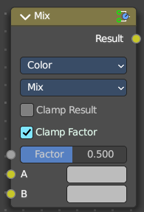
Mix Color
The mix Color node is in real the Mix node in Color mode. It is shared across editors.
The Mix node is meant to mix values. This can be colors, or also a vector or a single value.
Note that the Mix Color node does not start in Color mode when you insert it from the sidebar due a techical limitation in the Blender Python api. Here you have to manually switch to the color mode.

Inputs

Factor
Controls the amount of influence the node exerts on the output image.

A
Usually the background image. The image size and resolution sets the dimensions of the output image.

B
Usually he foreground image.

Properties

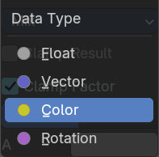
Data Type
The mode in which the node works.

Blending Mode

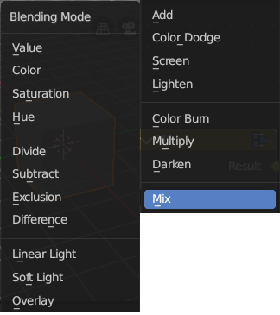
Mix
Choose the different blending modes.
Add, Subtract, Multiply, Screen, Divide, Difference, Darken, Lighten, Overlay, Color Dodge, Color Burn, Hue, Saturation, Value, Color, Soft Light, Linear Light.

Clamp Result
Clamp the result to 0, 1 range.

Clamp Factor
Clamp the factor to 0, 1 range.

Outputs

Result
Standard output.

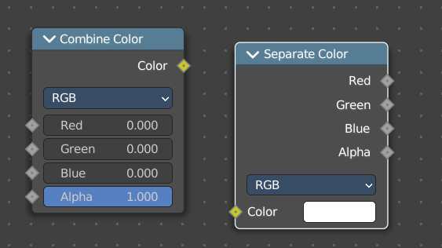
Combine Color
Combine the single RGBA channels into a single image.

Input

Mode
- RGB colour processing
- HSV colour processing
- HSL colour processing

Input – RGB mode

R, G and B
The red, green and blue channels of an image.

Input – HSV mode

H , S and V
The Hue, Saturation and Value channels of an image.

Input – HSL mode

H , S and L
The Hue, Saturation and Luminescence channels of an image.

Outputs

Color
The rgba output color.

Separate Color
Combine the single RGBA channels into a single image.

Input

Mode
- RGB colour processing
- HSV colour processing
- HSL colour processing

Image
The image input.

Output

Red, Green, Blue and Alpha
The red, green, blue and alpha channels of an image in RGB mode.

Hue Saturation Value Alpha
The Hue Saturation Value Alpha channels in HSV mode.

Hue Saturation Lightness Alpha
The Hue Saturation Lightness Alpha channels in HSL mode.

